Ex.no:5 | DATA VISUALIZATION USING MATPLOTLIB
Date:

Aim:
To visualize dataset features and distributions using line charts, bar charts, pie charts, histograms, scatter plots, and box plots using Matplotlib.

ALGORITHM 1: LINE CHART
Objective: To visualize the average sleep duration for different age groups.
Steps
- Select the Age and Sleep Duration columns.
- Group the data according to age.
- Calculate the average sleep duration for each age.
- Plot the values using a line chart.
- Add title and axis labels.
- Display the graph.
Interpretation
The line chart shows how average sleep duration varies with age and helps identify changes in sleeping patterns across different age groups.
age_sleep = df.groupby("Age")["Sleep Duration"].mean()
plt.figure(figsize=(10,5))
plt.plot(age_sleep.index, age_sleep.values, marker='o')
plt.title("Average Sleep Duration by Age")
plt.xlabel("Age")
plt.ylabel("Average Sleep Duration (Hours)")
plt.grid(True)
plt.show()

ALGORITHM 2: BAR CHART
Objective: To compare the average sleep duration among different occupations.
Steps
- Select the Occupation and Sleep Duration columns.
- Group the data according to occupation.
- Calculate the average sleep duration.
- Create a bar chart.
- Add title and axis labels.
- Display the chart.
Interpretation
The bar chart compares the average sleep duration among different occupations and helps identify occupations with higher or lower average sleep duration.
occupation_sleep = df.groupby("Occupation")["Sleep Duration"].mean()
plt.figure(figsize=(10,6))
plt.bar(occupation_sleep.index, occupation_sleep.values)
plt.title("Average Sleep Duration by Occupation")
plt.xlabel("Occupation")
plt.ylabel("Average Sleep Duration (Hours)")
plt.xticks(rotation=45)
plt.show()

ALGORITHM 3: PIE CHART
Objective: To visualize the distribution of different sleep disorders.
Steps
- Select the Sleep Disorder column.
- Count the occurrences of each sleep disorder.
- Calculate their proportions.
- Create a pie chart.
- Display percentage labels.
- Add a suitable title.
Interpretation
The pie chart shows the percentage distribution of people with different sleep disorders and those without a reported sleep disorder.
sleep_disorder = df["Sleep Disorder"].fillna("None").value_counts()
plt.figure(figsize=(8,6))
plt.pie(
sleep_disorder.values,
labels=sleep_disorder.index,
autopct='%1.1f%%'
)
plt.title("Sleep Disorder Distribution")
plt.show()

ALGORITHM 4: HISTOGRAM
Objective: To visualize the distribution of sleep duration.
Steps
- Select the Sleep Duration column.
- Divide the sleep-duration values into intervals or bins.
- Create a histogram using Matplotlib.
- Add title and axis labels.
- Display the histogram.
Interpretation
The histogram shows the frequency distribution of sleep duration and helps understand how many people sleep for different numbers of hours.
plt.figure(figsize=(8,5))
plt.hist(df["Sleep Duration"], bins=10)
plt.title("Distribution of Sleep Duration")
plt.xlabel("Sleep Duration (Hours)")
plt.ylabel("Frequency")
plt.show()

ALGORITHM 5: SCATTER PLOT
Objective: To analyze the relationship between physical activity level and sleep duration.
Steps
- Select Physical Activity Level as the X-axis variable.
- Select Sleep Duration as the Y-axis variable.
- Plot the observations using a scatter plot.
- Add title and axis labels.
- Display the graph.
Interpretation
The scatter plot helps identify whether there is a visible relationship between physical activity level and sleep duration.
plt.figure(figsize=(8,5))
plt.scatter(
df["Physical Activity Level"],
df["Sleep Duration"],
alpha=0.5
)
plt.title("Physical Activity Level vs Sleep Duration")
plt.xlabel("Physical Activity Level")
plt.ylabel("Sleep Duration (Hours)")
plt.show()

ALGORITHM 6: BOX PLOT
Objective: To visualize the distribution and identify possible outliers in sleep duration.
Steps
- Select the Sleep Duration column.
- Remove missing values if present.
- Create a box plot using Matplotlib.
- Add a suitable title and axis label.
- Display the plot.
Interpretation
The box plot shows the central distribution of sleep duration and helps identify unusually high or low sleep-duration values.
plt.figure(figsize=(7,5))
plt.boxplot(df["Sleep Duration"].dropna())
plt.title("Sleep Duration Box Plot")
plt.ylabel("Sleep Duration (Hours)")
plt.show()
ALGORITHM 7: MULTIPLE LINE CHART
Objective: To compare average sleep duration and average quality of sleep across different age
Steps
- Calculate average sleep duration for each age.
- Calculate average quality of sleep for each age.
- Arrange both datasets according to age.
- Plot average sleep duration using a line chart.
- Plot average quality of sleep using another line on the same graph.
- Add labels and a legend.
- Display the graph.

Interpretation
The multiple line chart allows comparison of sleep duration and sleep quality across different age groups and helps identify changes in sleeping patterns.
sleep_duration = df.groupby("Age")["Sleep Duration"].mean()
sleep_quality = df.groupby("Age")["Quality of Sleep"].mean()
plt.figure(figsize=(10,5))
plt.plot(
sleep_duration.index,
sleep_duration.values,
marker='o',
label="Sleep Duration"
)
plt.plot(
sleep_quality.index,
sleep_quality.values,
marker='s',
label="Quality of Sleep"
)
plt.title("Sleep Duration and Quality of Sleep by Age")
plt.xlabel("Age")
plt.ylabel("Average Value")
plt.legend()
plt.grid(True)
plt.show()

Output:
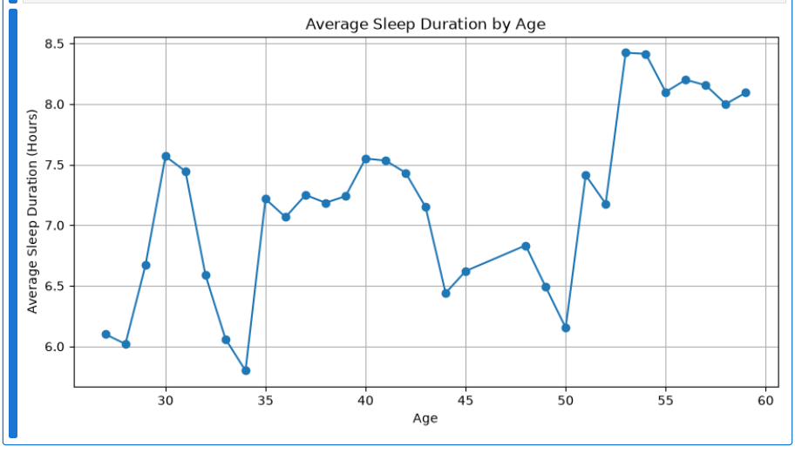
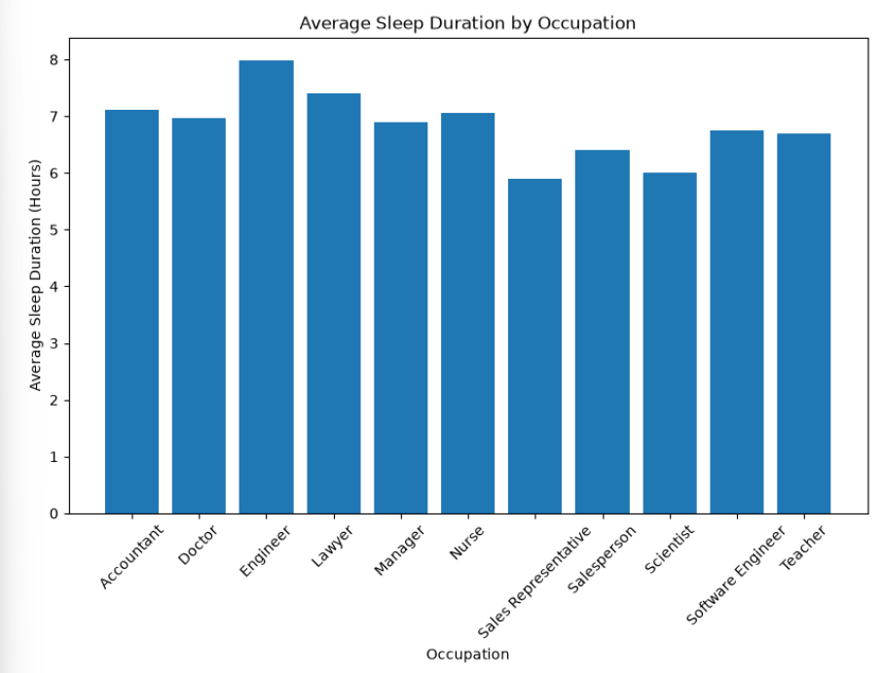
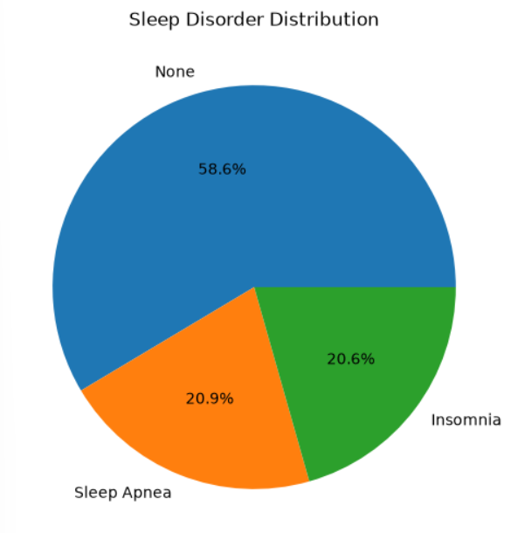
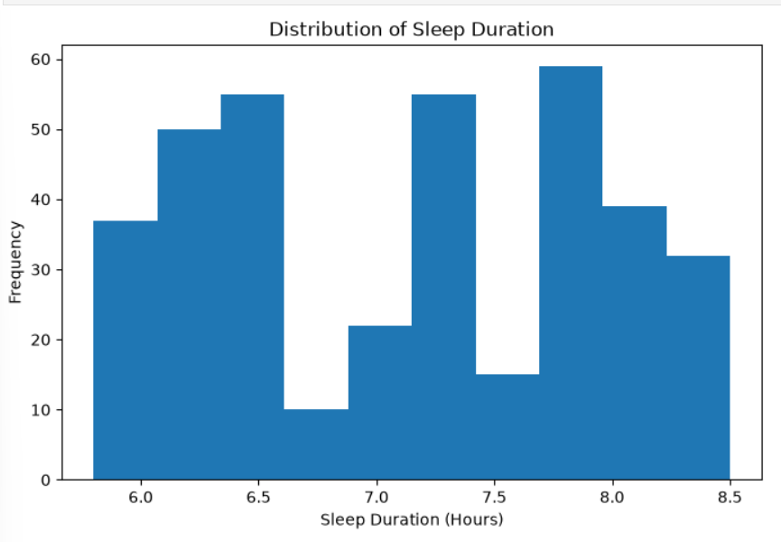
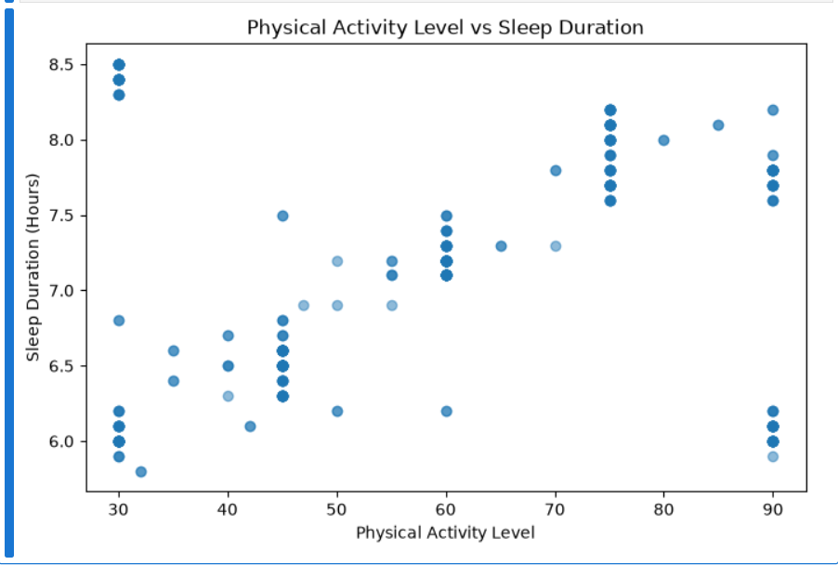
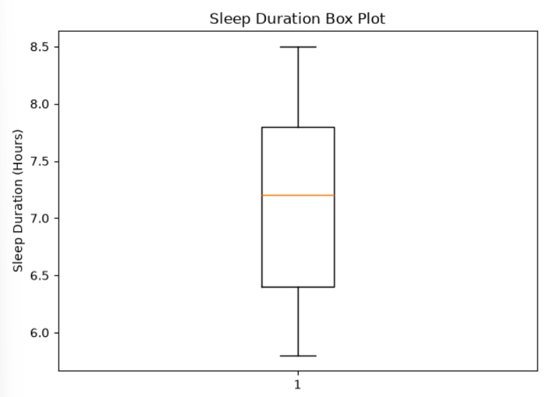
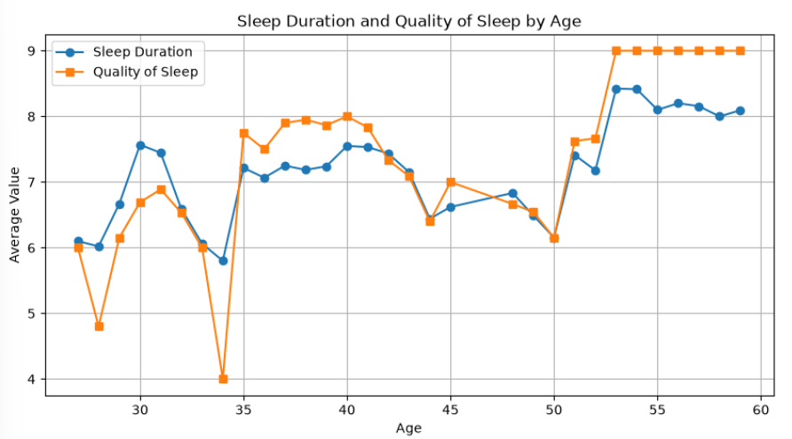

Result:

